Threat Model

Automated software vulnerability
discovery, exploitation, and patching
Henry Post, hp2376@nyu.edu, NYU-CS-GY-6813
The threat, in this problem domain (Automated software vulnerability discovery, exploitation, and patching) comes from external systems that would automatically scan open-source software (OSS) source code, parse it, detect vulnerabilities, and then attempt to exploit those vulnerabilities.
We need to protect the customers that consume the OSS itself from undiscovered bugs in the software. The vulnerability exists because vulnerable software is released at all, in any capacity. Attackers take advantage of the time that it takes maintainers of OSS to detect vulnerabilities, patch the code, and then deploy patches to customers. This time is valuable to an attacker, as it means that they can attempt to exploit the vulnerability in systems that are unpatched.
“Customer” in this context means any individual, organization, or even other software components that consume the OSS. For example, a “customer” could be you, if you used Apache Tomcat (webserver software) to host a personal website. It could also be Canonical Ltd., the current maintainers of the Ubuntu distribution of Linux, because they likely use nginx (network load balancer software) to host various websites, and nginx is OSS.
Ideally, the vulnerabilities would be detected earlier in the software development lifecycle (SDLC), before code was ever released to customers. This can be done by performing automated security scanning earlier (“shifting security left”) in the software development lifecycle.
Attackers have various methods and motives for targeting OSS, and the attack methods are very diverse. They occur after we release the vulnerable software into the wild. The OWASP Top Ten list is a good starting point to understand what kind of attacks could be performed on insecure software.

The diagram below shows a very simplified view of the SDLC lifecycle, focusing on vulnerability generation and how vulnerabilities are exploited and fixed.
Note that in this diagram I use “bug” and “vulnerability” interchangeably.
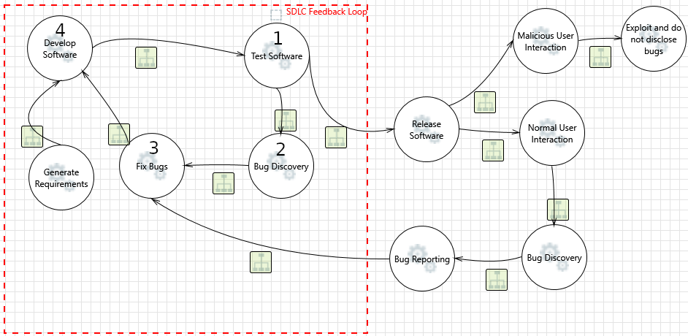
Our goal is to prevent vulnerabilities from being introduced in releases (“Release Software”). In order to do this, we need to ensure that vulnerabilities are always discovered within the SDLC Feedback Loop (red box) and not outside of it. We cannot rely on our users to report on vulnerabilities, and we cannot rely on malicious users to not exploit vulnerabilities. Therefore, we must ensure that we do not introduce vulnerabilities outside of the SDLC.
The fact that bugs ever leave the SDLC Feedback Loop could be viewed as a failure of one or more of the processes within the loop. One or more nodes must be modified, or one or more nodes must be added/removed.
- Develop Software
  - This is where bugs are generated.
  - The fact that bugs are generated here is a failure of this node.
    - Improve developer training/security mindset.
    - Replace human developers with automated (AI/robot) developers that are less error-prone.
    - Improve development processes
      - Utilize defensive programming/paradigms
        - Design-by-contract
        - Fail-fast
        - Strong typing
        - Typestate analysis
        - Formal verification
        - etc
- Test Software
  - This is where bugs should be detected and fixed.
  - The fact that bugs are not detected here is a failure of this node.
    - Improve testing procedures
      - Unit testing
        - Require full code coverage
    - Improve software analysis
      - SAST/DAST/IAST scanning
      - Scan code as it is run in a test system
      - Scan code as it is compiled
      - Scan code while it is written inside the IDE (editor) by a developer
      - Scan code after it is checked-in to a version control system (VCS)
- Bug Discovery
  - This is the process of realizing a bug exists, recording its existence, and/or fixing it.
- Fix Bugs
  - This is the process of performing code changes to fix a vulnerability (bug).

Aside from
remove me ;p

- Understand your system
- Understand what assets/resources need to be protected
- Predict who the potential attackers are against a particular asset and what are the possible (known) attacks
- Perform risk assessment. Determine what is the expected risk (quantitative or qualitative) because of an attack
- Perform risk management: Employ security mechanisms (mitigation), if needed. Determine if they are cost effective

